**Project Design Phase-II Data Flow Diagram &User Stories**

|  |  |
| --- | --- |
| Date | 16 October 2022 |
| Team ID | PNT2022TMID35939 |
| Project Name | Medicine Reminder |
| Maximum Marks | 4 Marks |

**DATA FLOW DIAGRAM**

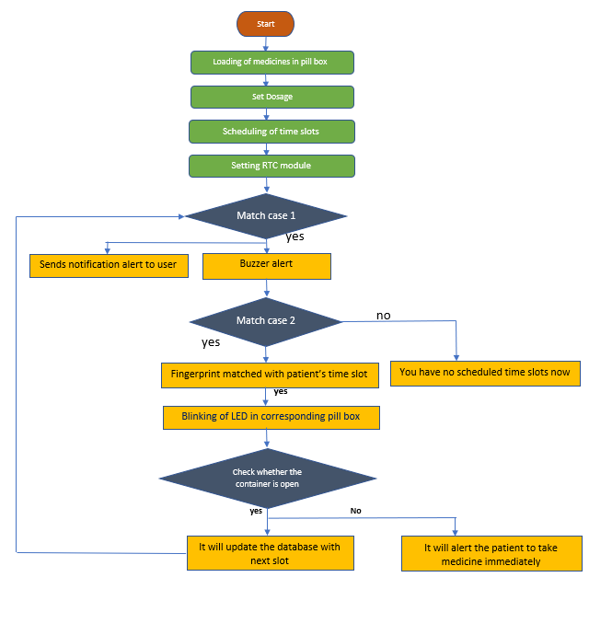

**USER STORIES:**

|  |  |  |  |  |  |  |
| --- | --- | --- | --- | --- | --- | --- |
| **User Type** | **Functional**  **Requirement (Epic)** | **User**  **Story Number** | **User Story / Task** | **Acceptance criteria** | **Priority** | **Release** |
| Customer (Senior user) | caretaker | USN-1 | As a user, I want to take Medicines on time and monitor my health | I want to take medicines on time | High | Sprint-1 |
| Customer (Diabetes Patient) | Smart medicine box | USN-2 | As a user, I want to take my tablets on time by voice command | I want to take my tablets on time by voice command | High | Sprint-1 |
| Customer (Thyroid  Patient) | Smart medicine box | USN-3 | As a user, my patient needs to take medicines on time and  monitoring the activity | My patient needs to take medicines  on time | Medium | Sprint-2 |
| Customer (Coma Patient ) | Caretaker | USN-4 | As a user, my patient needs medication time and prescription should load indatabase for upcoming week | My patient medication time and prescription should be in  database list | low | Sprint-4 |
| Customer (Disabled People’s) | Smart medicinebox | USN-5 | As a user ,i need to take my medicine in nearby places with light notification | I need to take my medicine in nearby places with light  notification | Medium | Sprint-3 |